**MATHEMATICS FOR COMPUTING**

***WEEK 3 - SEMINAR***

**LOGARITHMS AND ROOTS OF POLYNOMIALS**

**Learning Outcomes**

By the end of the seminar the successful student will be able to:

* Basic concepts of logarithms
* Working with polynomials – addition, subtraction, multiplication and division

**Lecture Recap:**

1. Logarithm is…
2. A logarithm is the power to which a number must be raised in order to get some other number.
3. A logarithm is the power to which a number must not be raised in order to get some other number.
4. None of them

Ans: a

1. Logarithms characterize how many times you need to fold a sheet of paper to get 64 layers. Every time you fold the paper in half, the number of layers doubles. Mathematically speaking, 2 (the base) multiplied by itself a certain number of times is 64. How many multiplications are necessary?
2. log2(64) = 5 b. log2(64) = 6 c. log2(64) = 4 d. log2(64) = 3

Ans: b

1. We write "the number of 2s we need to multiply to get 8 is 3" as:
2. log2 (3) = 8 b. log2 (8) = 3 c. log3 (8) = 2

Ans: b

1. Describe the same relationship between a, b, and c.



1. *b* is the base, *c* is the argument, *a* is exponent
2. *b* is the exponent, *c* is the argument, *a* is base
3. *b* is the base, *c* is the exponent, *a* is argument
4. All of them

Ans: C

1. A polynomial can have any number of terms but not infinite.
2. True b. False

Ans: a

1. How many terms can trinomial have?
2. 3 b. 2 c. 1 d. 0

Ans: a

1. Which one is true to solve linear polynomials?
2. Solving Linear Polynomials: First, isolate the variable term and make the equation as equal to one. Then solve as basic algebra operation. First, rewrite the expression in the descending order of degree. Then, equate the equation and perform polynomial factorization to get the solution of the equation.
3. Solving Linear Polynomials: First, isolate the variable term and make the equation as equal to zero. Then solve as basic algebra operation. First, rewrite the expression in the ascending order of degree. Then, equate the equation and perform polynomial factorization to get the solution of the equation.
4. Solving Linear Polynomials: First, isolate the variable term and make the equation as equal to zero. Then solve as basic algebra operation. First, rewrite the expression in the descending order of degree. Then, equate the equation and perform polynomial factorization to get the solution of the equation.
5. All of them

Ans: C

# Introduction to Logarithms

# Logarithms are another way of thinking about exponents. In its simplest form, a logarithm answers the question: How many of *one number* do we multiply to get *another number?*

# 

### How to write it?

We write "the number of 2s we need to multiply to get 8 is 3" as:

log2 (8) = 3

Here are more examples of equivalent logarithmic and exponential equations.

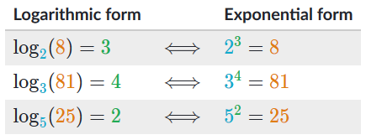

**Task 1:**

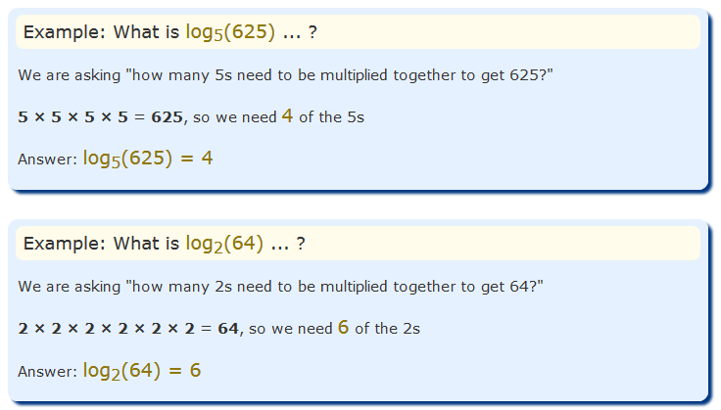

## Definition of a logarithm

Generalizing the examples above leads us to the formal definition of a logarithm.



Both equations describe the same relationship between a, b, and c:

* *b* is the base.
* *c* is the exponent, and
* *a* is called the argument.

**Exercise Task 1:** What is log10 (100)?

**Exercise Task 2:** What is log3 (81)?

## Negative Logarithms

**Task 2:**

We can have just one divide:

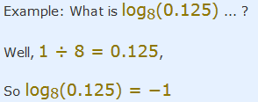

Or many divide:

**Task 3:**

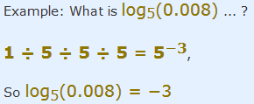

**Exercise Task 3:** What is log10 (0.01)?

**Exercise Task 4:** What is log10 (0.0001)?

# Polynomials

* Constants. Example: 1, 2, 3, etc.
* Variables. Example: g, h, x, y, etc.
* Exponents: Example: 5 in x5 etc.

### Notation

The polynomial function is denoted by P(x) where x represents the variable. For example,

P (x) = x2 - 5x + 11

If the variable is denoted by a, then the function will be P (a).

## Degree of a Polynomial

The [degree of a polynomial](https://byjus.com/maths/degree-of-a-polynomial/) is defined as the highest degree of a monomial within a polynomial. Thus, a polynomial equation having one variable which has the largest exponent is called a degree of the polynomial.

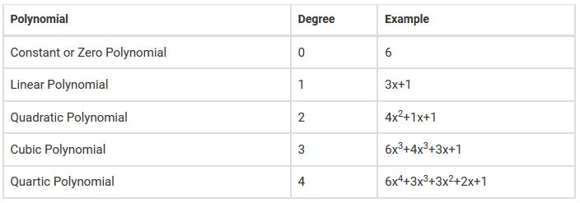

**Task 4:** Find the degree of the polynomial 6s4+ 3x2+ 5x +19

**Solution:**

The degree of the polynomial is 3.

## Terms of a Polynomial

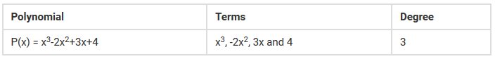

## Types of Polynomials

* **Monomial**
* **Binomial**
* **Trinomial**

## Polynomial Equations

The polynomial equations are those expressions which are made up of multiple constants and variables. The standard form of writing a [polynomial equation](https://byjus.com/maths/polynomial-equations/) is to put the highest degree first then, at last, the constant term. An example of a polynomial equation is:

b = a4 +3a3 -2a2 +a +1

## Solving Polynomials

* Solving Linear Polynomials
* Solving Quadratic Polynomials

### Solving Linear Polynomials

Getting the solution of linear polynomials is easy and simple. First, isolate the variable term and make the equation as equal to zero. Then solve as basic algebra operation. An example of finding the solution of a linear equation is given below:

**Task 5:** Solve 3x – 9

**Solution:**

First, make the equation as 0. So,

3x – 9 = 0

⇒ 3x = 9

⇒ x = 9/3

Or, x = 3.

Thus, the solution of 3x-9 is x = 3.

### Solving Quadratic Polynomials

To solve a quadratic polynomial, first, rewrite the expression in the descending order of degree. Then, equate the equation and perform [polynomial factorization](https://byjus.com/maths/factorization-of-polynomials/) to get the solution of the equation. An example to find the solution of a quadratic polynomial is given below for better understanding.

**Task 6:** Solve 3x2 – 6x + x3 – 18

**Solution:**

First, arrange the polynomial in the descending order of degree and equate to zero.

⇒ x3 + 3x2 -6x – 18 = 0

Now, take the common terms.

x2 (x+3) – 6(x+3) = 0

⇒ (x2-6) (x+3) = 0

So, the solutions will be x = -3 and x2 = -6.

## Polynomial Operations

There are four main polynomial operations which are:

* Addition of Polynomials
* Subtraction of Polynomials
* Multiplication of Polynomials
* Division of Polynomials

Each of the operations on polynomials is explained below using solved examples.

### Addition of Polynomials

To add polynomials, always add the like terms, i.e. the terms having the same variable and power. The addition of polynomials always results in a polynomial of the same degree. For example,

**Task 7:** Find the sum of two polynomials: 5x3+3x2y+4xy−6y2, 3x2+7x2y−2xy+4xy2−5

**Solution:**

First, combine the like terms while leaving the unlike terms as they are. Hence,

(5x3+3x2y+4xy−6y2) + (3x2+7x2y−2xy+4xy2−5)

= 5x3+3x2+(3+7)x2y+(4−2)xy+4xy2−6y2−5

= 5x3+3x2+10x2y+2xy+4xy2−6y2−5

### Subtraction of Polynomials

Subtracting polynomials is similar to addition, the only difference being the type of operation. So, subtract the like terms to obtain the solution. It should be noted that subtraction of polynomials also results in a polynomial of the same degree.

**Task 8:** Find the difference of two polynomials: 5x3+3x2y+4xy−6y2, 3x2+7x2y−2xy+4xy2−5

**Solution:**

First, combine the like terms while leaving the unlike terms as they are. Hence,

(5x3+3x2y+4xy−6y2) - (3x2+7x2y−2xy+4xy2−5)

= 5x3-3x2+ (3-7)x2y+(4+2)xy-4xy2−6y2+5

= 5x3-3x2-4x2y+6xy-4xy2−6y2+5

### Multiplication of Polynomials

Two or more polynomial when multiplied always results in a polynomial of higher degree (unless one of them is a constant polynomial). An example of [multiplying polynomials](https://byjus.com/maths/multiplying-polynomials/) is given below:

**Task 9:** Solve (6x−3y) × (2x+5y)

**Solution:**

⇒ 6x × (2x+5y)–3y × (2x+5y) ———- Using distributive law of multiplication

⇒ (12x2+30xy) – (6yx+15y2) ———- Using distributive law of multiplication

⇒12x2+30xy–6xy–15y2 —————– as xy = yx

Thus, (6x−3y) × (2x+5y)=12x2+24xy−15y2

### Division of Polynomials

The fourth arithmetic operation is division, the inverse of multiplication. Division of polynomials isn’t much different from division of numbers. In the exponential section, you were asked to simplify the following expressions such as:



This expression is the division of two monomials. To simplify it, we divided the coefficients and then divided the variables.

**Task 10:**

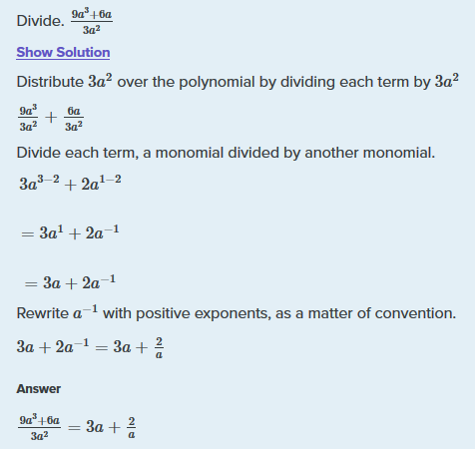

This example shows how to do this when dividing by a **binomial**.

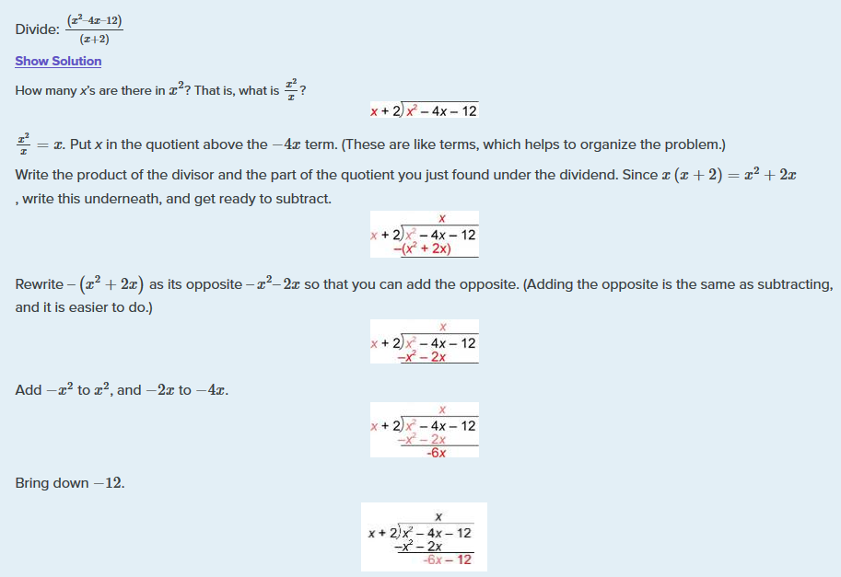

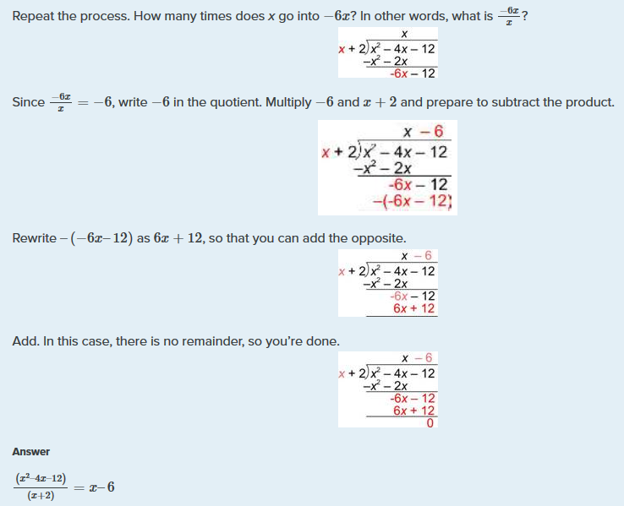

**Exercise Task 5:**

Given two polynomial 7s3+2s2+3s+9 and 5s2+2s+1, solve these using all mathematical operation.

**Homework Task:**

1. Identify the coefficient, variable, and degree of the variable for the following monomial terms:

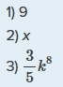

1. Simplify 3x2 − 5x2.

**References**

1. <https://www.purplemath.com/modules/polydefs.htm>
2. <https://www.mathplanet.com/education/algebra-2/polynomial-functions/basic-knowledge-of-polynomial-functions>
3. <https://tutorial.math.lamar.edu/classes/alg/polynomials.aspx>
4. <https://www.livescience.com/50940-logarithms.html>
5. <https://www.khanacademy.org/math/algebra2/x2ec2f6f830c9fb89:logs/x2ec2f6f830c9fb89:log-intro/a/intro-to-logarithms>
6. <https://www.youtube.com/watch?v=ZvL9aDGNHqA>